# Purpose

Ffreedom has shared a new requirement to calculate the Average Revenue per Plan (ARPP). ARPP will be calculated per Action plan. The actual purpose of ARPP is to calculate the commission on product which is recommended by Freedom during financial planning.

**ARPP will have two major values**

* Expected revenue = Based on the Action plan
* Actual revenue = Based on the Execution tracker respect with action plan

**Expected revenue** = According to Financial planning client (Entity) will assigned an action plan to complete his/ her goals. In action plan Freedom team suggest some products to Invest like Mutual Funds, Life Insurance and General Insurance to the client.

**Actual revenue =** for each action plan one or more execution tracker will be created to capture the progress of the action plan. According to Execution Tracker the actual commission will be calculated.

# ARPP ERD

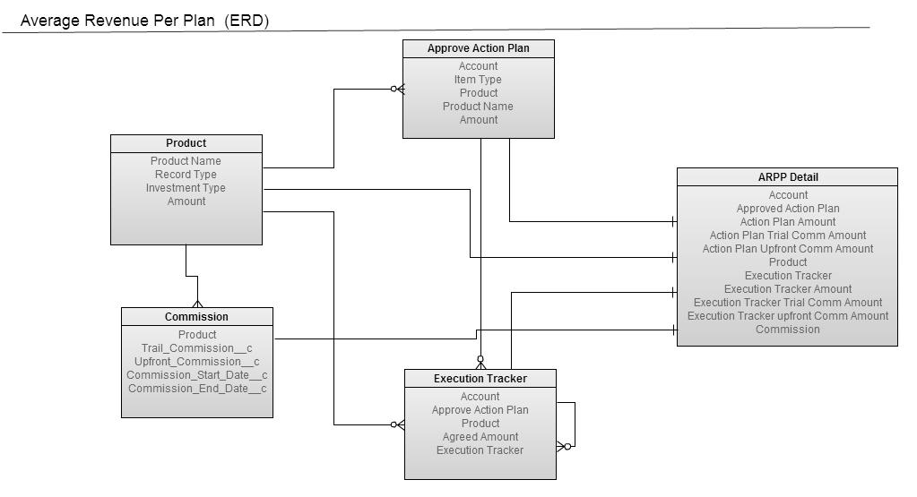

**Object Design**

ARPP Detail Object

|  |  |  |
| --- | --- | --- |
| Sr. No | **Field Label** | **Data Type** |
| 1 | Action Plan | Look up |
| 2 | Action Plan Amount | Number(16,2) |
| 3 | Action plan Total revenue | Number(16,2) |
| 4 | Action Plan Upfront Comm Amount | Number(16,2) |
| 5 | Action Plan Trial Comm Amount | Number(16,2) |
| 6 | Execution Tracker | Look up |
| 7 | Execution Tracker Amount | Number(16,2) |
| 8 | Execution Tracker Total revenue | Number(16,2) |
| 9 | Execution Tracker Upfront Comm Amount | Number(16,2) |
| 10 | Execution Tracker Trial Comm Amount | Number(16,2) |
| 11 | Product | Look up |
| 12 | Remark | Text Area |
| 13 | Commission | Look up |

Commission Object

|  |  |  |
| --- | --- | --- |
| Sr. No | **Field Label** | **Data Type** |
| 1 | Commission Start Date | Date |
| 2 | Commission End Date | Date |
| 3 | Commission Owner | Picklist |
| 4 | Commission Period | Picklist |
| 5 | Commission Type | Picklist |
| 6 | Effective Start Date | Date |
| 7 | FF Commission % | Percent(16,2) |
| 8 | is Reconciled | Checkbox |
| 9 | Max Year Value | Number(2,0) |
| 10 | Min Year Value | Number(2,0) |
| 11 | Partner Commission % | Percent(16,2) |
| 12 | Product | Lookup |
| 13 | Product Name | Formula Field |
| 14 | Reconciliation Date time | Date |
| 15 | Reconciliation Difference Remarks | Date |
| 16 | Trail Commission | Percent(4,2) |
| 17 | Is Active | Checkbox |
| 18 | Upfront Commission | Percent(4,2) |

**Product Configuration**

Product configuration will have access for account team only. Financial planner will not have access to create product. Financial planner will only add products from the product master list in Action Plan.

Freedom products configuration is mainly divided 2 types

1. **Ffreedom Service product**: Freedom solution suit Item will fall in this category. Financial plan is based on the Freedom Service Product. ARPP calculation will not get applied for Ffreedom Service Product.
2. **Freedom Recommended Product**: Freedom Recommended products are products which are added in the action plan.

|  |  |
| --- | --- |
| **Product Type** | **Product Names** |
| Ffreedom Service product | Ffreedom Product Services |
| Value Added Services |
| Freedom Recommended Products | General Insurance |
| Life Insurance |
| Mutual Fund |

Only Freedom recommended products will have commission on it. The following products are recommended in action plan currently.

|  |  |  |
| --- | --- | --- |
| **Sr No** | **Product Type** | **Sub type** |
| 1 | Mutual fund | Lumpsum |
| Sip |
| 2 | Life Insurance | Term Life |
| Whole Life |
| Endowment |
| ULIP-Dept |
| ULIP-Equity |
| Pension Plan |
| Money-Back |
| Children’s |
| Other |
| 3 | General Insurance | **Medical Insurance** |
| 1. Medical |
| 1. Critical illness |
| 1. Personal Accident |
| 1. Top Up |
| **Asset Insurance** |
| 1. Vehicle |
| 1. Householder’s |
| 1. Others |

**Commission Configuration**

* Product will be the parent for commission object.
* Freedom Recommended Productcan have one or more commissions on it.
* System will take care that at a time only one commission will be activated for product.
* ARPP calculations are based on the product added in the action plan and activate commission on product.

|  |  |  |  |
| --- | --- | --- | --- |
| **Sr No** | **Recommended Product Type** | **Upfront commission** | **Trail commission** |
| 1 | Mutual fund | Yes | Yes |
| 2 | Life Insurance | Yes | NO |
| 3 | General Insurance | Yes | NO |

**Graphical User Interface**

Each Entity will have ARPP Detail button on it.

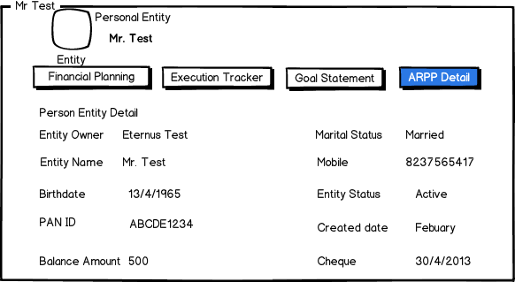

When financial planner will click on ARPP detail button planner will be redirected to the Custom visualforce Page in the same window.

Page will display Action Plan data and respective ARPP Details and Execution tracker details in the tabular format. There are some action plans in which more than one execution tracker records will be created in the Freedom system. Page will display only parent execution tracker on the ARPP detail Visualforce page, child execution tracker details will not be shown.

Following will be the primary VF page Mockup.

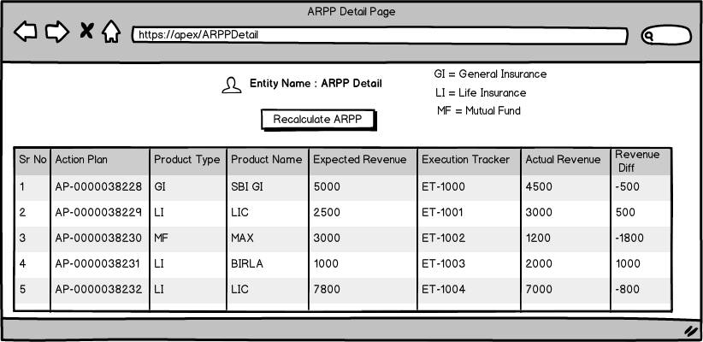

**Process Flow**

1. Account Team will configure the recommended products in the Product Master

* Life Insurance
* General Insurance
* Mutual Funds

1. For eachrecommended productsFinancial planner will add respective commissions

* Trail
* Upfront

1. Financial Planner will create action plan and will add recommended Products in it.
2. When action plan Inserted in the background Trigger will be get fired on the action plan Insert / Update and ARPP record will be get calculated and inserted in the system. ARPP expected commission it depends upon the recommended products commission which is configured in the product master table.
3. When action plan updated with new product ARPP expected value also updated by trigger automatically. (ARPP recalculation will be done automatically)
4. When Execution tracker created for action plan same ARPP record will be updated with the actual commission. Actual commission depends upon the amount which is entered in the execution tracker for particular Action Plan.
5. For each Action Plan one ARPP get created with expected commotion. When one or more execution tracker started with respect to the action plan same ARPP record will be get updated with the actual commission value.

**ARPP Calculation**

* Create ARPP records after creation of Action Plan records and calculate actual Upfront and Trail Commission base on Investment / Product type.
* After Insert trigger on Approve Action Plan object to Crate ARPP detail records.

Following steps are using to Calculating actual commission:

1. Collect All Action Plan record where ET has opened and store APs separately based on Type (SIP/Lumpsum/LI/GI) and
2. Collect suggest products from Product Master.
3. Executed Each Category of Action plan newly created records and create corresponding ARPP records. While creating ARPP record with Upfront and Trail commission calculation we have checked Following Condition.
4. If Product name is not available on Product Master Object then Put Remark “Product Detail is not found”.
5. If Product name is found but active commission is not available then put remark “Commission Detail is not found”.
6. In Case of Life Insurance section find the valid year’s interval active Commission detail.
7. In case of SIP, Lumpsum and General Insurance find only active Commission detail.
8. ARPP detail is having reference fields of Approve Action Plan, Product Master, Execution tracker and Commission. When we are creating new ARPP record at same time we are initializing all reference fields except Execution Tracker.
9. **Commission Calculation Formula for Each Category :**
10. **SIP**

**Upfront Commission:** use following formula

|  |
| --- |
| ARPPDetail.Action_Plan_Upfront_Comm_Amount =  (Commission.Upfront Commission * 12) *ActionPlan.Amount)/100 ; |

Ex: ActionPlan.Amount = 5000

Commission.Upfront_Commission = .5%

Then ARPP.Upfront_Comm_Amount = (5000 * 12* .5) /100;

**Trail Commission:**

|  |
| --- |
| Double amount = ActionPlan.Amount;  For (Integer i = 0; i < 12; i++){  trailComm += (amount * Commission.Trail_Commission)/100;  Amount += ActionPlan.Amount;  }  ARPPDetail. Action Plan Trial Comm Amount = trailComm; |

**Upfront and Trail Commission Calculation for SIP:**

Commission.Upfront_Commission = .5%

Commission.Trail_Commission = .04%

|  |  |  |  |  |
| --- | --- | --- | --- | --- |
| **Month** | **SIP Amount** | **Total Investment = AUM** | **Trial Commission** | **Upfront Commission** |
| 1 | 5000 | 5000 | 2 | 25 |
| 2 | 5000 | 10000 | 4 | 25 |
| 3 | 5000 | 15000 | 6 | 25 |
| 4 | 5000 | 20000 | 8 | 25 |
| 5 | 5000 | 25000 | 10 | 25 |
| 6 | 5000 | 30000 | 12 | 25 |
| 7 | 5000 | 35000 | 14 | 25 |
| 8 | 5000 | 40000 | 16 | 25 |
| 9 | 5000 | 45000 | 18 | 25 |
| 10 | 5000 | 50000 | 20 | 25 |
| 11 | 5000 | 55000 | 22 | 25 |
| 12 | 5000 | 60000 | 24 | 25 |
| TOTAL Revenue for Year 1: | |  | 156 | 300 |

1. **Lumpsum :**

**Upfront Commission:**  upfront comm. calculation is similar to SIP upfront calculation.

**Trail Commission:** ARPPDetail.Action_Plan_Trail_Comm_Amount =

(Commission.Trail Commission * 12) *ActionPlan.Amount)/100 ;

1. **Life Insurance**

**Upfront Commission:** Find the appropriate Commission Detail and apply valid commission

if(Commission.Min_Year_Value <= ActionPlan.Tenure_of_Insurance__c && ActionPlan.Tenure of Insurance < Commission.Max_Year_Value)

**Calculate upfront commission:**

|  |
| --- |
| ARPPDetail.Action_Plan_Upfront_Comm_Amount = (Commission.Upfront_Commission * ActionPlan.Sum_Assured_Rs/100) |

Ex: Life Insurance Action Plan. Sum Assured = 100000 ActionPlan.Tenure_of_Insurance__c = 14 objARPPDetail.Action_Plan_Upfront_Comm_Amount = (100000 * 20)/100 **Here 20 is valid commission as per below table**.

Money back polices commission structure is as follows:

|  |  |  |  |
| --- | --- | --- | --- |
| **Year** | **0 to 10 years** | **10 to 15 years** | **> 15 years** |
| 1 | 15% | 20% | 28% |
| 2 | 10% | 10% | 10% |
| 3 | 10% | 10% | 10% |
| 4 | 5% | 5% | 5% |
| ….. | 5% | 5% | 5% |
| End of term | 5% | 5% | 5% |

**Trail Commission:** No need to calculate trail commission. Here trail commission always 0.

1. **General Insurance**

|  |
| --- |
| **Upfront commission:** Insurance is always for 1 year.  ARPPDetail.Action_Plan_Upfront_Comm_Amount = Commission.Upfront_Commission * l ActionPlan.Sum_Assured_Rs )/100 |

**Trail Commission:** No need to calculate trail commission. Here trail commission always 0

* Using above steps we have created ARPP records with Action Plan records. Following steps are mentioning how we are relating Execution tracker with ARPP detail record.

1. After Insert and update trigger on Execution Tracker.
2. ARPP record will updated when Execution tracker is created or updated.
3. Execution tracker records are directly related with Action Plan record therefore first we are collecting all Action plan references from ET and retrieving All ARPP detail records related to collected Action Plan references.
4. Since ARPP have all required reference so using Commission reference we have calculated Upfront and Trail (only for SIP) commission. Execution_Tracker_Trial_Comm_Amount and Execution_Tracker_Trial_Comm_Amount ARPP detail fields hold Upfront and trail commission respectively.
5. Here commission calculation formula is similar to Actual Commission calculation. For calculating Executed Amount upfront and trail commission make bit change above mentioned formulas than use “ExecutionTrakcer.Executed_Amount” field rather than ActionPlan.Amount and ActionPlan. Sum_Assured_Rs.

**Note:** When ET record is created at that time Executed Amount is zero. This amount field by OPs team member with “Closed “ ET status.

**Component Involved in the ARPP Detail**

|  |  |  |  |
| --- | --- | --- | --- |
| Sr No | Name | Type | Comment |
| 1 | ActionPlanTrigger | Trigger | Insert / Update |
| 2 | ExecutionTrigger | Trigger | Insert / Update |
| 3 | ARPPCalculationHandler | Handler Class | Class will handle the ARPP calculations |
| 4 | ARPPDetail | VF | Graphical representation of ARPP Detail |
| 5 | Commission Trigger | Trigger | Trigger will give error message when more than one commission will be activated on same product |
| 6 | ARPPDetailController | ControllerClass |  |

**Data migration**

Data migration Steps as bellow

1. Insert Freedom recommended products in product master with respective commission.
2. Update existing action plan for existing entity
   1. Export existing Action Plan from production org and replace product name with respective Product master Id and update via data loader (manual Process).
3. Update existing Execution tracker with respective action plan product and commission.
   1. Export existing Execution Tracker from production update product lookup with respect to action plan product by using data loader.

**Impacts on the current system**

1. Product Master will be updated
2. Each product recommended product master will have one or more product on it.
3. Existing Action plan will be updated with Product Master lookup
4. Existing Execution Tracker will be updated with Product Master Lookup and with active commission on it.
5. For existing data ARPP will be calculated with the current commission.

**For Current MF Lumpsum we are using following details:**

* Hold - Change of Broker - No Revenue
* STP From - Upfront Revenue -No Trail Revenue   
  STP To - Upfront & Trail Revenue as per fund - from the product master
* Switch Out - No Revenue
* Switch In - Upfront & Trail Revenue as per fund from the product master
* Hold - No Upfront, only Trail Commission
* Hold - Existing Fund (This field needs to be added in the dropdown) - No Revenue.

**For Current MF SIP**

* Stop - No Revenue
* Continue - Upront and Trail Revenue
* Exisitng SIP COB - Upront and Trail Revenue
* Continue - Existing SIP (This field needs to be added in the dropdown) - No Revenue.